What Was Installed vs. What the Pole Can Actually Hold
Two different disciplines sit behind most aerial network projects, and depending on where the project is happening, only one of them might actually get done. Aerial As-Built and Pole Loading Analysis get talked about as if they're variations on the same task, paperwork with different names. They aren't. One is a record of what was installed. The other is a calculation of what the pole can actually hold. Treating them as interchangeable is how a perfectly documented pole ends up carrying more than it was ever rated for, with nobody finding out until wind or ice makes the point for them.
An Aerial As-Built survey has one clear job: record exactly what's physically installed on a pole. Field crews record pole locations and heights, cable and hardware placement, guy wires and anchors, exactly as installed. That rarely matches the original design, once permits, terrain and contractor judgment calls have had their say. That data feeds GIS platforms and asset registers, and for a lot of operational purposes, that's the job done. It tells an engineer what's physically on a pole today.
What it doesn't tell you is whether the pole itself can safely carry that load.
Pole Loading Analysis answers that separately, and it's engineering, not documentation. Pole class, span length, conductor tension and sag, attachment heights, and regional wind and ice loads all feed into the calculation. It's checked against whatever electrical safety code applies in that market. Both the code and the loading district, the specific combination of wind and ice conditions a pole in that area has to withstand, change by country, and often by region within it. The output is a utilization figure. Take a pole calculated at 110 percent of its rated capacity: that figure has nothing to do with paperwork. It means the pole may not survive the next serious storm, regardless of how accurately someone recorded what's hanging off it.

How As-Built and PLA Fit Into One Project

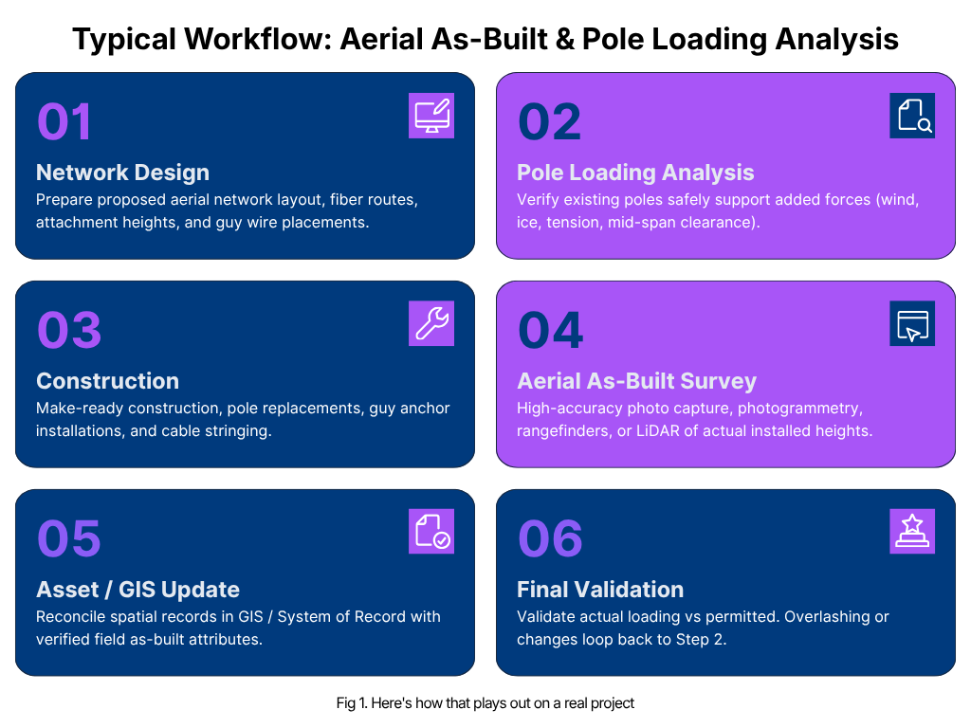
A project done right follows the same steps, in the same order, every time. Design comes first, routes and span lengths and proposed attachments drawn up before anyone touches a pole. Loading analysis follows immediately after, checked against the proposed load rather than what's already there. Catching a structural problem at the design stage is cheap. Catching it once cable is already strung is not. A pole that fails that check doesn't mean starting over. It usually means going back and fixing the pole itself, what the industry calls make-ready work: rearranging existing attachments to redistribute load, adding guying, reinforcing the pole, or replacing it outright. That gets more complicated once other parties already have equipment on the same pole, a setup known as joint use, which is the case more often than not. The calculation has to account for everything already up there, not only whatever's being added.
Construction happens after that, largely uneventfully if the earlier steps were done properly. The as-built survey follows, capturing what actually went up. That data flows back into GIS and asset systems, not as a filing exercise but as the input the next loading check will eventually need, whenever the next attached wants space on that same pole. A new attachment, cable over lashed onto an existing line, storm damage, a pole simply getting older, any of these can reopen the question. When that happens, the cycle goes back to the loading calculation rather than staying closed.

When Operators Skip the Structural Check
In markets where Pole Loading Analysis isn't strictly mandated, it's common for that cycle to stop early. The as-built survey gets done, the GIS gets updated, and the project gets treated as complete, because from a compliance standpoint in that particular jurisdiction, it technically is. The structural question just never got asked.
That gap rarely shows up on a normal day. It shows up during the exact conditions the loading calculation exists to test for. And a pole failing under load doesn't fail quietly or in isolation. It takes down whatever's attached to it in that moment, often power and fibre together, along with every customer whose service runs through that stretch. Weighing that outcome against the cost of a structural check, one a regulator simply didn't require, isn't much of a decision at all.

Why This Works Best as One Connected Process
This sequence rewards being handled as one continuous process rather than a set of disconnected vendors. The value of accurate field survey work compounds directly into the loading calculation. And the value of a correct loading calculation compounds into how usable the resulting as-built and GIS records are downstream.
That's why the combination matters: high-precision GPS data collection at the survey stage, GIS posting that keeps records genuinely current rather than static, and QA/QC running through each stage of the cycle rather than bolted on at the end. It's the same combination JSAN brings to aerial documentation and structural verification work, treating both as one connected process rather than two separate line items. That's what keeps the two disciplines from drifting apart. On projects handled by whoever happened to win each separate contract, that drift is exactly what tends to happen.
A pole doesn't ask which discipline was responsible for checking it. It just holds, or it doesn't.

